Node.js Installation
Node.js is a Javascript WebServer we are going to used in our Lab. It is a very popular Webserver and is used in many cloud based implementations.
You may already have it on your system. So let's test it.

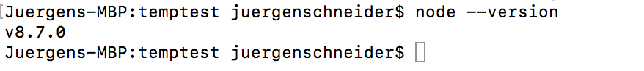
With Node.js we also typically will use NPM as package manager. NPM is needed to install additional packages as we move along. So if you have Node.js you will most likely also have NPM.
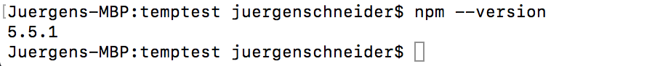

If not let's download and install it.

Use this link: https://nodejs.org/en/download/

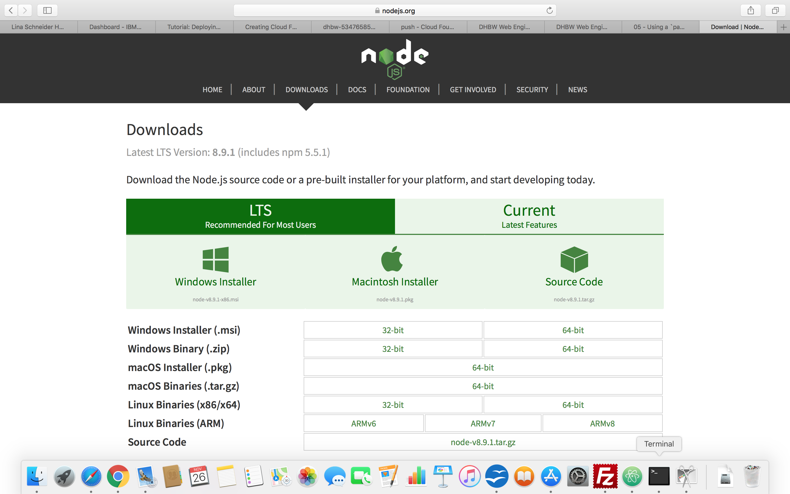
After the download run the installation for your platform.

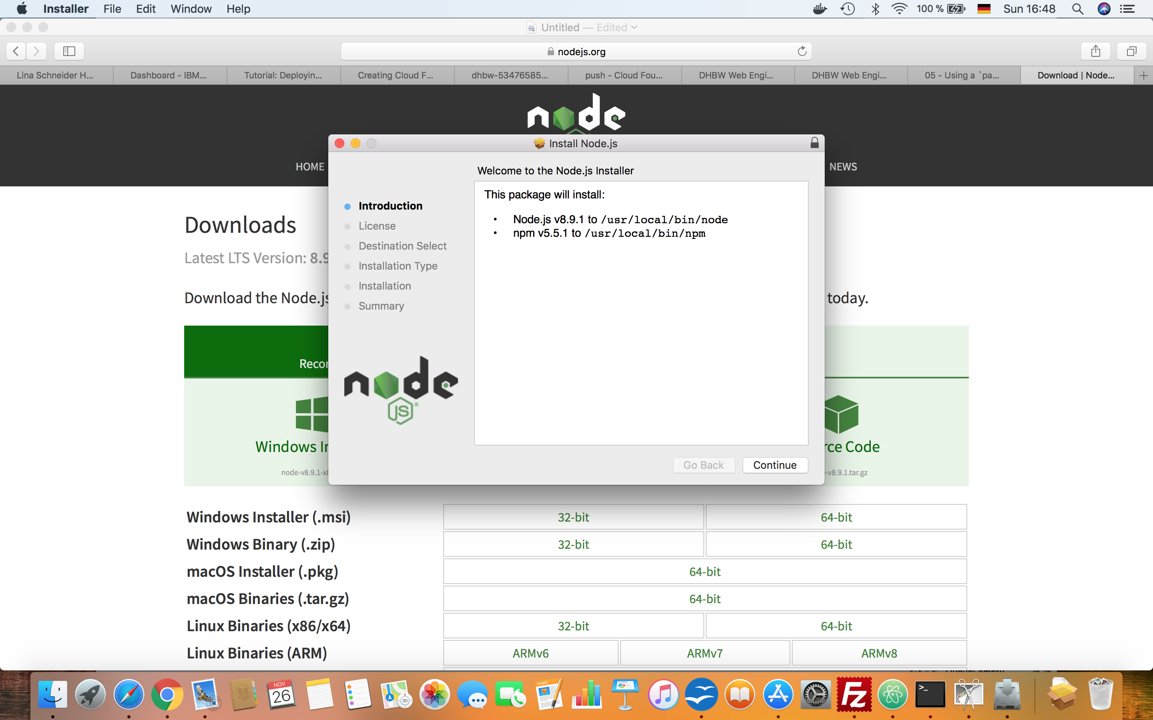
Verify the installation
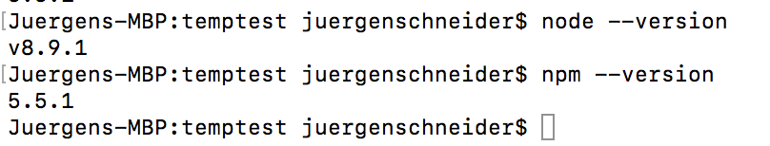

Congratulations

We are close but not yet there. The next step is to use the following Github repository for some more information.
https://github.com/JuergenSchneiderDHBW/DHBWLectures.git

Here you will find two folders :
- Labs (for the lab exercises we will do. This folder will grow with our exercises moving along
- Scripts (here you find Juergen's scripts for your further reading)

To complete our Node.JS installation including all the plugins we download the package .json to a our local directory we will use for our exercises.
- Make a new directory md webexercise
- Download the package.json form the github into this new directory
- jump into that directory and execute
  - webexercise> NPM install
You see a lot of downloads into a new folder names node_modules.

Now we are really done !!

